Zid’Avwa Al Bari’i
244107020083 / TI – 2I / 26
All the code here is on GitHub
https://github.com/ZidAvwa/CollegeStudy/tree/main/3rdSemester/15.%20Jobsheet15

Jobsheet 15

Experiment 1

Tables
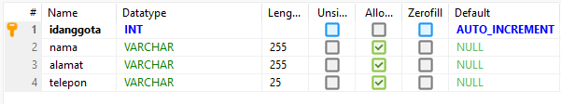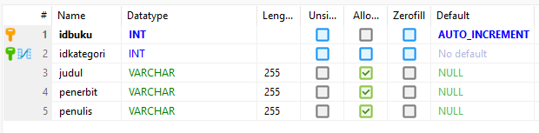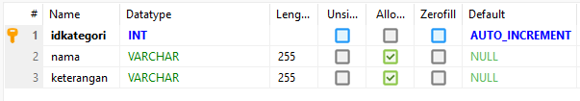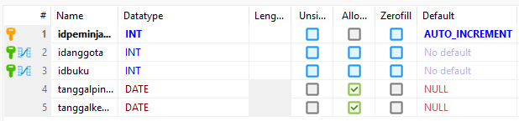

Experiment 2
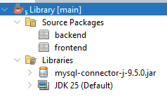

Experiment 3 & 4
Too long to screenshot. So I put it on my GitHub.

Experiment 5
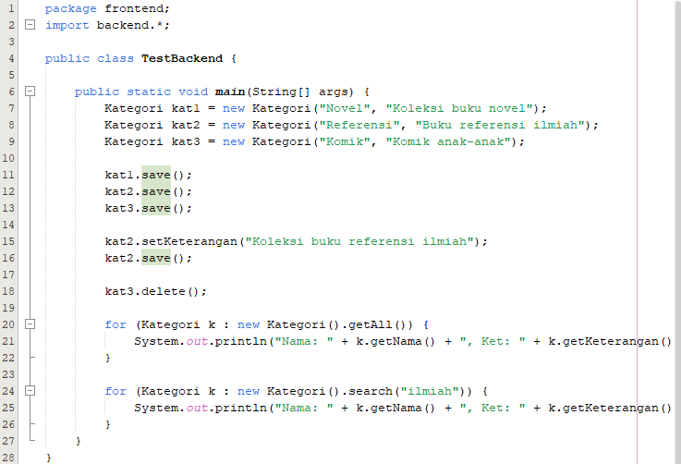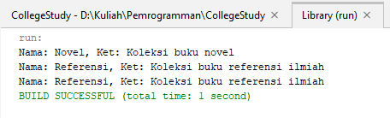

Experiment 6
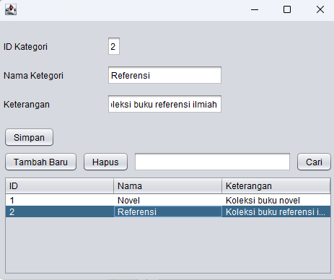

Experiment 7
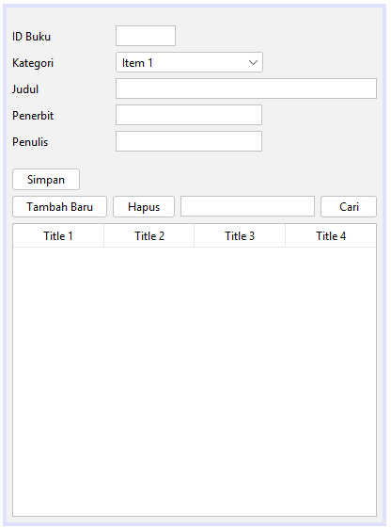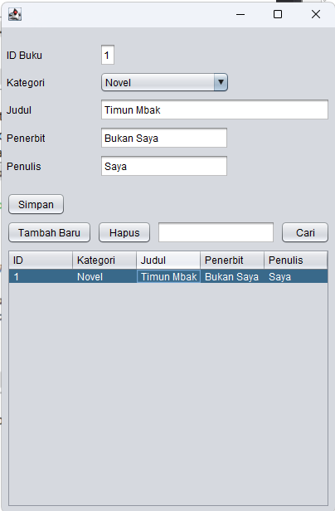

TASK
